Semi-automatic double head shoe material masking film rewinding machine ZRTB-2S
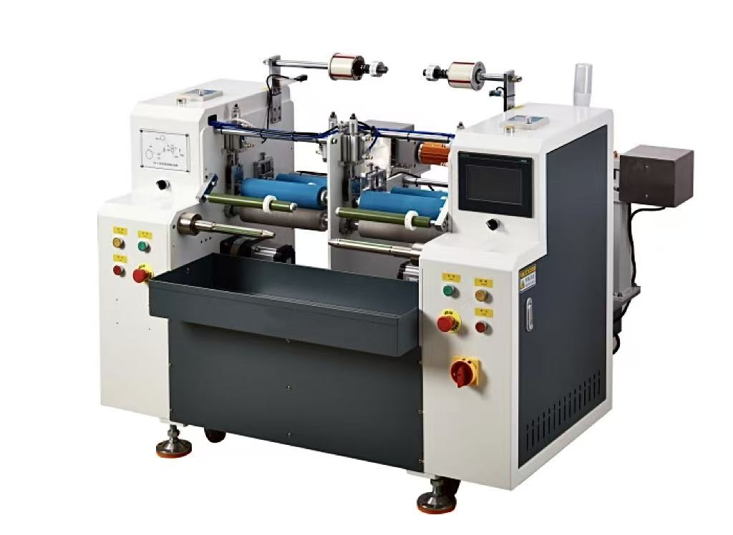

Basic Use：
It is mainly used for the winding and laminating device and film roll of the shoe material

Product characteristics：
- servo motor torque winding.
- Automatic tension release, tension stability, edge control, flat fit. Start and stop roll smoothly.
- The servo motor pulls the material, and the length is calculated accurately.
- The unwinding adopts manual expansion shaft, which is convenient and fast for loading and unloading.
- No film alarm, no tape alarm, no material alarm.
- One key to start, easy to operate.
Main Technical Parameters：
Model | ZRTB-2S
paper core | Customized according to customer requirements
Unwinding master roll | ≤600mm
Rewinding diameter | <150mm
Rewind width | Φ（50-200）mm
Production speed | 4-7pcs/MIN （Subject to rewinding length）
power supply | 4P220V 50/60HZ/3KW
air pressure | 0.5MPa
Machine size | 1460*1560*1200
Net Weight | 451KG
Configuration parameters：
model | ZRTB-2S
touch screen | Mcgstpc
Edge corrector | ARISE
Magnetic powder clutch | YOSEEN
air switch | chint
switching power supply | Mingwei
Edge correction power supply | Mingwei
photoelectric sensor | OMRON
Material detection sensor | DCF
contactor | Schneider
relay | Schneider
Button switch | Kndele
Tri-color warning light | TʌYB
Solenoid valve | China STNC
Cylinder | CNTUOPU
Rodless cylinder | CNTUOPU
Linear slide | HIWIN
Magnetic switch | AIRTAC
bearing | NSK，HRB
drive spindle | Embossed Teflon surface anti-stick treatment
nip roll | Silicone lagging (non-adhesive)
scalpel | 40MM tungsten steel round knife
transition roller | Anti-skid belt surface treatment (to prevent material running)

